|  |
| --- |
| Photo displaying partial image of two pie charts on a canvas-textured page |
| Clear Thinking Clinic  Presented by SHUN LEI WATY |
| |  |  |  | | --- | --- | --- | | NVL Institute |  | Computer Networks | |



**NCC Education**

**LEVEL 4 DIPLOMA IN COMPUTING**

**COMPUTER NETWORKS**

|  |
| --- |
| Centre Name : NVL INSTITUTE  Assignment Title : CLEAR THINKING CLINIC  Exam Cycle : DECEMBER 2018  Candidate Name : SHUN LEI WATY  NCC Education ID No : XXXXXX  Submission Date : 31.Oct.2018 |
| Marker’s Comments :  Moderator’s Comments :  Mark: Moderated Mark: Final Mark: |



**Statement and Confirmation of Own Work**

***Each time you submit an assignment you must attach this statement as the cover page for both the hard copy and the electronic version. If the statement is missing, your work will not be marked.***

**Student Declaration**

I have read and understood NCC Education’s Policy on Academic Dishonesty and Plagiarism.

I can confirm the following details:

**Programme/Qualification Name** : LEVEL 4 DIPLOMA IN COMPUTING

**Student ID/Registration Number** : XXXXXXXX

**Name**  : SHUN LEI WATY

**Centre Name** : NVL INSTITUTE

**Module Name**  : COMPUTER NETWORKS

**Module Leader** : U MIN THU KHANT

**Number of words** :

I confirm that this is my own work and that I have not plagiarized any part of it. I have also noted the assessment criteria and pass mark for assignments.

**Due Date** : 31. Oct.2018

**Student Signature**  : shun

Submitted Date : 31. Oct.2018

Contents

INTRODUCTION 5

ACKNOWLEDGEMENT 6

Task1: Network Infrastructure and Protocols 8

(a) 8

(b) OSI 7-layer Model 8

(c) Seven Protocols 9

(d) Hub, Switch, Wireless Access Point, Router 10

Task 2: Addressing 12

(a)Network Address and Host Address 12

(b)Private IPV4 and Public IPV4 Address 12

(c)DHCP 12

(d)Difference between IPV4 & IPV6 12

(e)Gateway 12

(f)Subnet mask 12

(g)IP Routing 12

Task 3: Security 14

(a)Three Main Security concepts 14

(b) 14

(c) 14

(d) 14

(e) 14

Task 4: Diagram and Explanation 17

(a)Logical Network Diagram 17

(b) 17

(c) 17

(d)Local Price and Specification of Hardware and Software 17

Task 5: Telephony 20

(a)What is VOIP? 20

(b) 20

(c) 20

CONCLUSION 21

REFERENCE 22

# INTRODUCTION

My name is Shun Lei Waty.

# ACKNOWLEDGEMENT

Thank you

TASK-1

# Task1: Network Infrastructure and Protocols

## (a)

## (b) OSI 7-layer Model

OSI 7-layer model are

1. Application layer
2. Presentation layer
3. Session layer
4. Transport layer
5. Network layer
6. Data link layer
7. Physical layer

**Application layer**

Application layer is supports application and end-user processes. Communication partners are identified, quality of service is identified, user authentication and privacy are considered, and any constraints on data syntax are identified. Everything at this layer is application-specific. This layer provides application-specific. This layer provides application services for file transfers, e-mail, and other network software services.

**Presentation layer**

Presentation layer is providing independence from differences in data representation by translating from application to network format, and vice versa. This layer formats and encrypts data to be sent across a network, providing freedom from compatibility problems. It is sometimes called the syntax layer.

**Session layer**

Session layer establishes, manage and terminated connections between applications. The session layer set up, coordinates, and terminates, exchanges, and dialogues between the applications at each end. It deals with session and connection coordination.

**Transport layer**

Transport layer provides transparent transfer of data between end systems, or hosts, and is responsible for end to end error recovery and flow control. It ensures complete data transfer.

Network layer provides switching and routing technologies, creating logical paths, known as virtual circuits, for transmitting data from node to node to node. Routing and forwarding are functions of this layer, as well as addressing, internetworking, error handling, congestion control and packet sequencing.

**Data Link Layer**

data packets are encoded and decoded and into bits. It furnishes transmission protocol knowledge and management and handles errors in the physical layer, flow control and frame synchronization. The data link layer divided into two sublayers: The Media Access Control (MAC) layer and the Logical Link Control (LLC) layer. The MAC sublayer controls how a computer on the network gains access to the data and permission to transmit it. The LLC layer controls frame synchronization, flow control and error checking.

**Physical layer**

Physical layer conveys the bit streams the bit stream – electrical impulse, light or radio signal- through the network at the electrical and mechanical level. It provides the hardware means of sending and receiving data on a carrier, including defining cables, cards and physical aspects.

## (c) Seven Protocols

Seven protocols are

* HTTP
* UDP
* IP
* SMTP
* FIP
* POP3
* DHCP

HTTP (Hypertext Transfer Protocol)

The Hypertext Transfer Protocol is an [application protocol](https://en.wikipedia.org/wiki/Application_protocol) for distributed, collaborative, [hypermedia](https://en.wikipedia.org/wiki/Hypermedia) information systems. HTTP is the underlying [protocol](https://www.webopedia.com/TERM/P/protocol.html) used by the [World Wide Web](https://www.webopedia.com/TERM/W/World_Wide_Web.html) and what actions [Web servers](https://www.webopedia.com/TERM/W/Web_server.html) and [browsers](https://www.webopedia.com/TERM/B/browser.html) should take in response to various commands. HTTP was developed to facilitate hypertext and the World Wide Web.

UPD (

IP (Network layer)

SMTP (Physical layer)

FIP (Application Layer)

## (d) Hub, Switch, Wireless Access Point, Router

TASK-2

# Task 2: Addressing

## (a)Network Address and Host Address

## (b)Private IPV4 and Public IPV4 Address

Internet Protocol Version (IPV4) is the fourth version in the internet protocol. Private IP network is a network that private IP address. Private IPV4 commonly use in residential, office and enterprise environment. Private IPV 4 address are special address. Private IP address are provided by network devices, such as routers, using network address translation. In real network environment, many devices which are inside a private network (Example -a local network Area Network (LAN) inside a company, a local area network (LAN) inside organization or a home network) did not need to communication with any device outside its own local Area Network. Even the computer inside a private network need to connect to internet, there is no need of directly of connectivity, they are connected to the internet via router any other end-point device. Private UIP address space were originally defined in an effort to delay IPV4 address exhaustion. Public IP address is accessible by anyone on the internet. Public IP address is an address which is assigned to a computer device to allow direct access to the internet. Public IPV4 can be made our which assist we to fully protect our sever access it from anywhere.

Range 10.0.0.0-10.255.255.255

Range 172.16.0.0-172.31.255.255

Range 192.168.0.0-192.168.255

## (c)DHCP

## (d)Difference between IPV4 & IPV6

IUPV4 is the fourth Version of internet but IPV 6 is the sixth Version of internet. The IPV 4 address length is 32 bits but IPV6 has 128 bits. IPV4 can generate 4.29 109.  IPV6 can produce quite a large number of address, i.e., 3.4 1038.  IPV4 can use class-type space for multicast use (224.0.0.0/4) but IPV 6 integrated address space for multicast, at FFOO: :/8. IPV 4 address can into classes with class A networks for a huge network. IPV 4 will use broadcast address which forced each device to stop and look at packet but IPV 6 can use multicast group. IPV4 not has packet flow identification. IPV 6 has packet flow identification is available within the IPV 6 header using the flow label field. IPV4 can get checksum field but IPV6 cannot get checksum. IPV4 also can get broadcast messages but IPV 6 cannot get. The binary numbers of IPV4 is decimals but IPV 6 is hexadecimal. IPV 4 is IPSec support only optional but IPV6 is inbuilt IPSec support.

## (e)Gateway

## (f)Subnet mask

## (g)IP Routing

TASK-3

# Task 3: Security

## (a)Three Main Security concepts

## (b)

## (c)

## (d)

## (e)

TASK-4

# Task 4: Diagram and Explanation

## (a)Logical Network Diagram

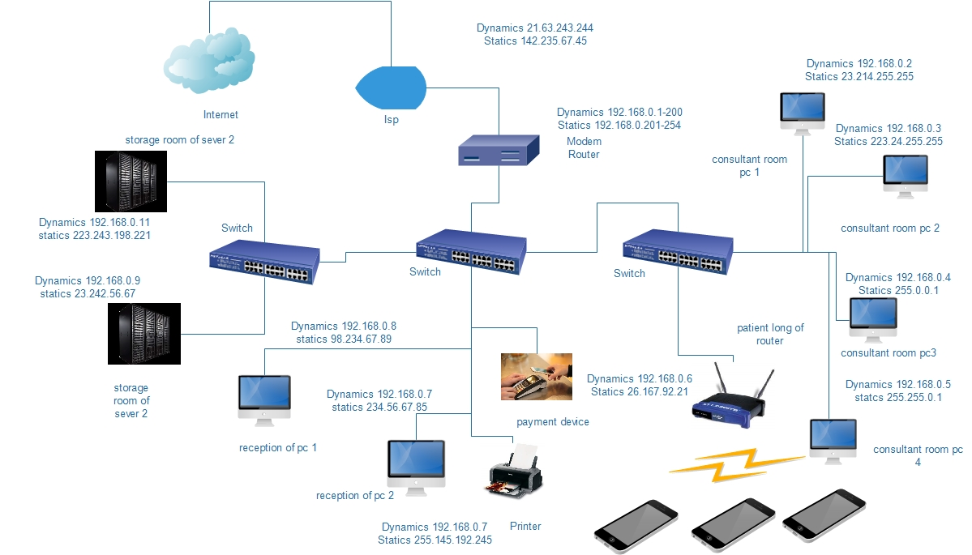

## (b)

## (c)

Above diagram connection involves internet, ISP, Modem router, computer, switches, server, payment device, network printer and wireless access point. We use internet this diagram because to connect with other country, know information, use the patient end etc. This use ISP to access the internet. We use modem router for connecting one or more user to use the internet. We computer use to control security, online payment, online boking and to look CCTV. Switches also use to get internet another computer. We should use payment device in reception for payment easy. We use wireless access point to pay the patient internet. We use database sever to store data. We also use Exchange sever to send mail, store mail and store booking.

## (d)Local Price and Specification of Hardware and Software

|  |  |  |  |  |
| --- | --- | --- | --- | --- |
| Network Component image | NO  Of component | Requirement device | Specification of component | Prices |
|  |  | Dell Inspiron 157000(PC) |  | $1,948 |
|  |  | ASUS RT-AC88U (wireless access point) |  | $1,080 |
|  |  | ARRIS SURF board SBG508 AC (modem router) |  | $329.99 |
|  |  | HP laser jet 8320 laser printer |  | $858 |
|  |  | Cash Cow 2017 newest model Credit card payment device |  | $315 |
|  |  | SUN T4-4 SPARC 4x  (sever) | 8-core  3GHz 128 Gb  Ram 2X 300GB | $2,950 |

TASK-5

# Task 5: Telephony

## (a)What is VOIP?

## (b)

## (c)

# CONCLUSION

In conclusion

# REFERENCE